**Pyber Data Analysis**

By Josefina Blanchard

Working with the data file for the Pyber rides by city, we wanted to organize the information in a summarized way in order to analyze it, we do that by grouping the information by city type and later on, by city.

When we look at the figures by city type, such categories (Rural, Suburban, and Urban) allow us to see that the majority of the rides provided are serviced on the urban areas, which would be expected with a larger population or demand for the Pyber rides. The total fares collected as well as the number of drivers available surpass the same variables for the Suburban and Rural areas combined.

The ratio of drivers available in the Rural areas is above 60%, we should consider not accepting more applicants from those areas to focus the support center resources on the more demanding cities to continue growing service quality and reputation.

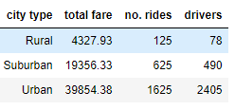

It better observed when visualizing the data segmented by city type in a scatter plot:

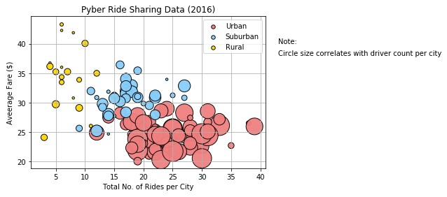

Looking at the average of fares collected, the total rides given, and the number of drivers available in individual charts, we can further support the concentration of services in the urban areas.

Using this information, we could focus our analysis in the services to the urban areas to determine if the number of drivers and the rates are appropriate or to assess the opportunity to expand the offer and increase our revenues.

